**Verzeo**

**Microsoft Azure Cloud Computing**

**Assignment-3**

*Name: Aarish Ahmed Siddique*

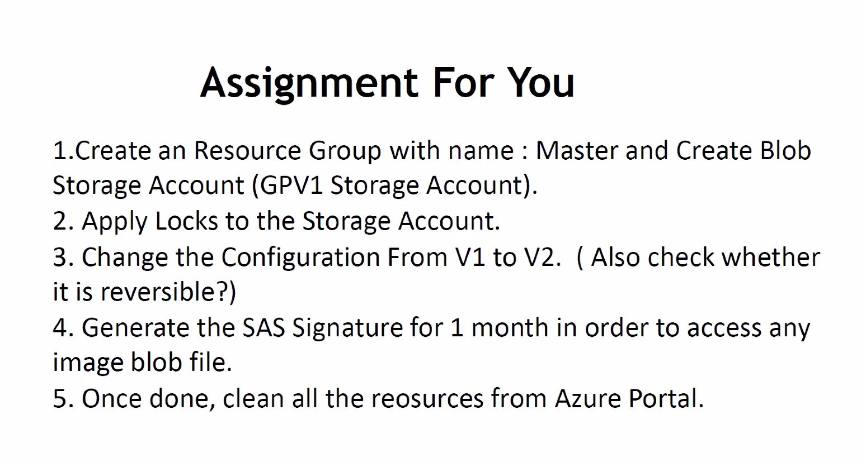

**1.1. Created resource group with name Master**

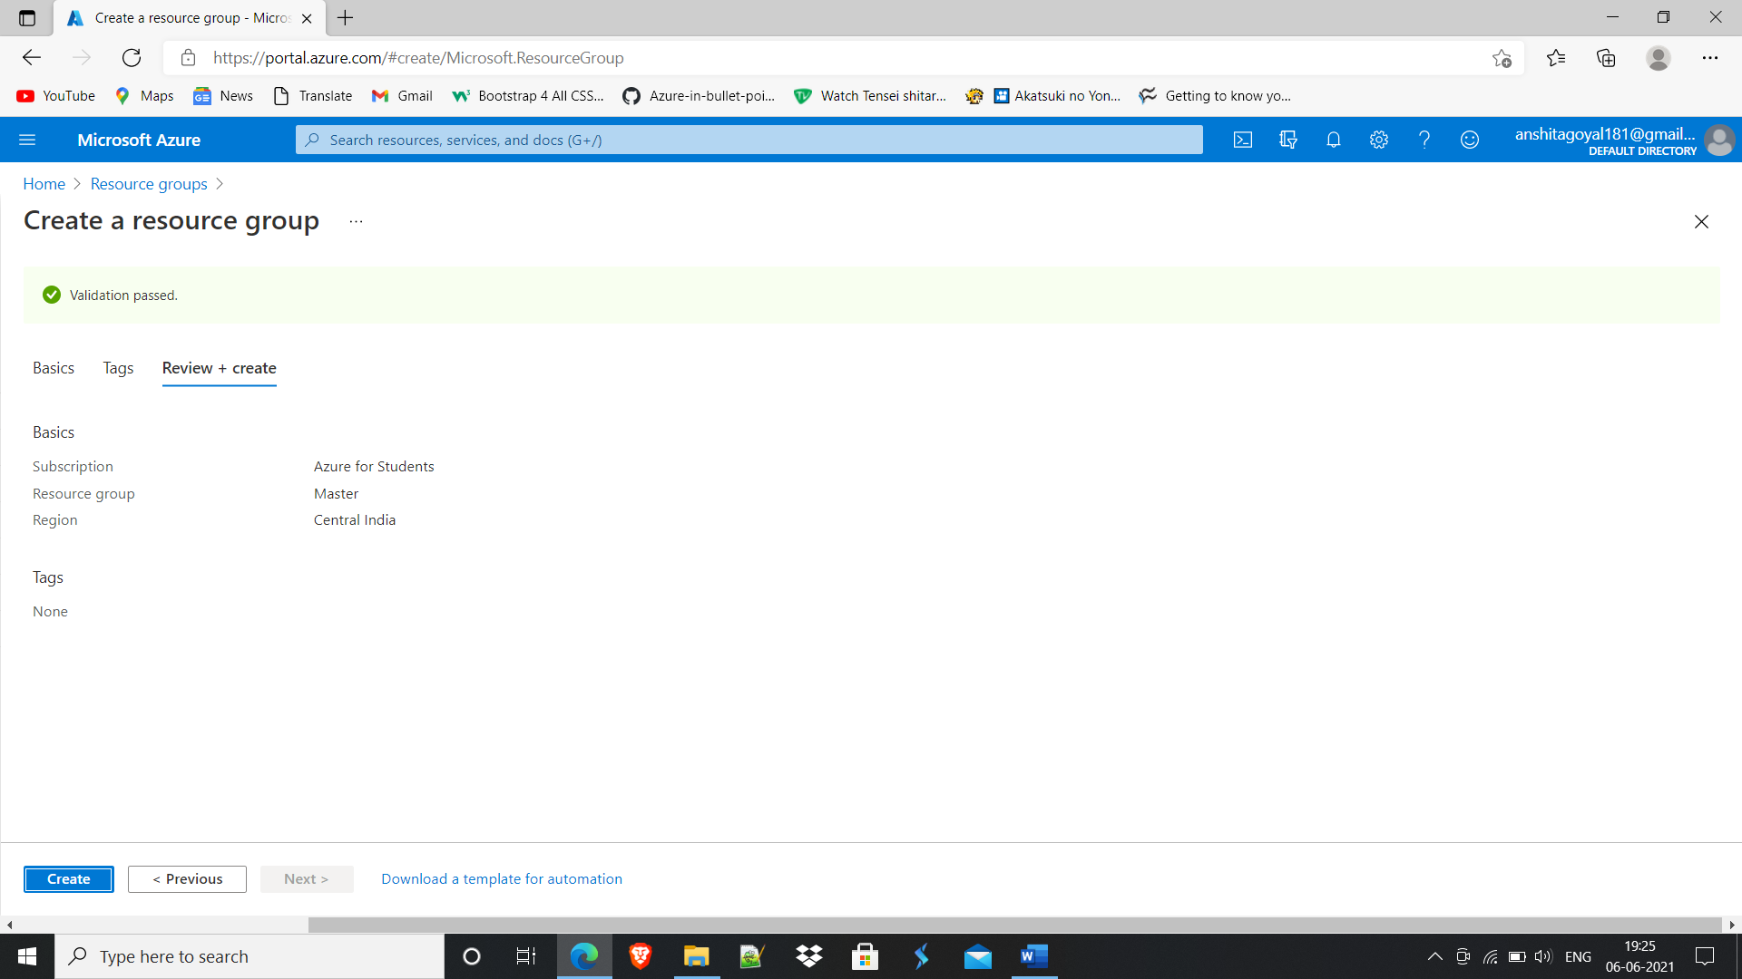

**1.2. Created GPV1 Storage account**

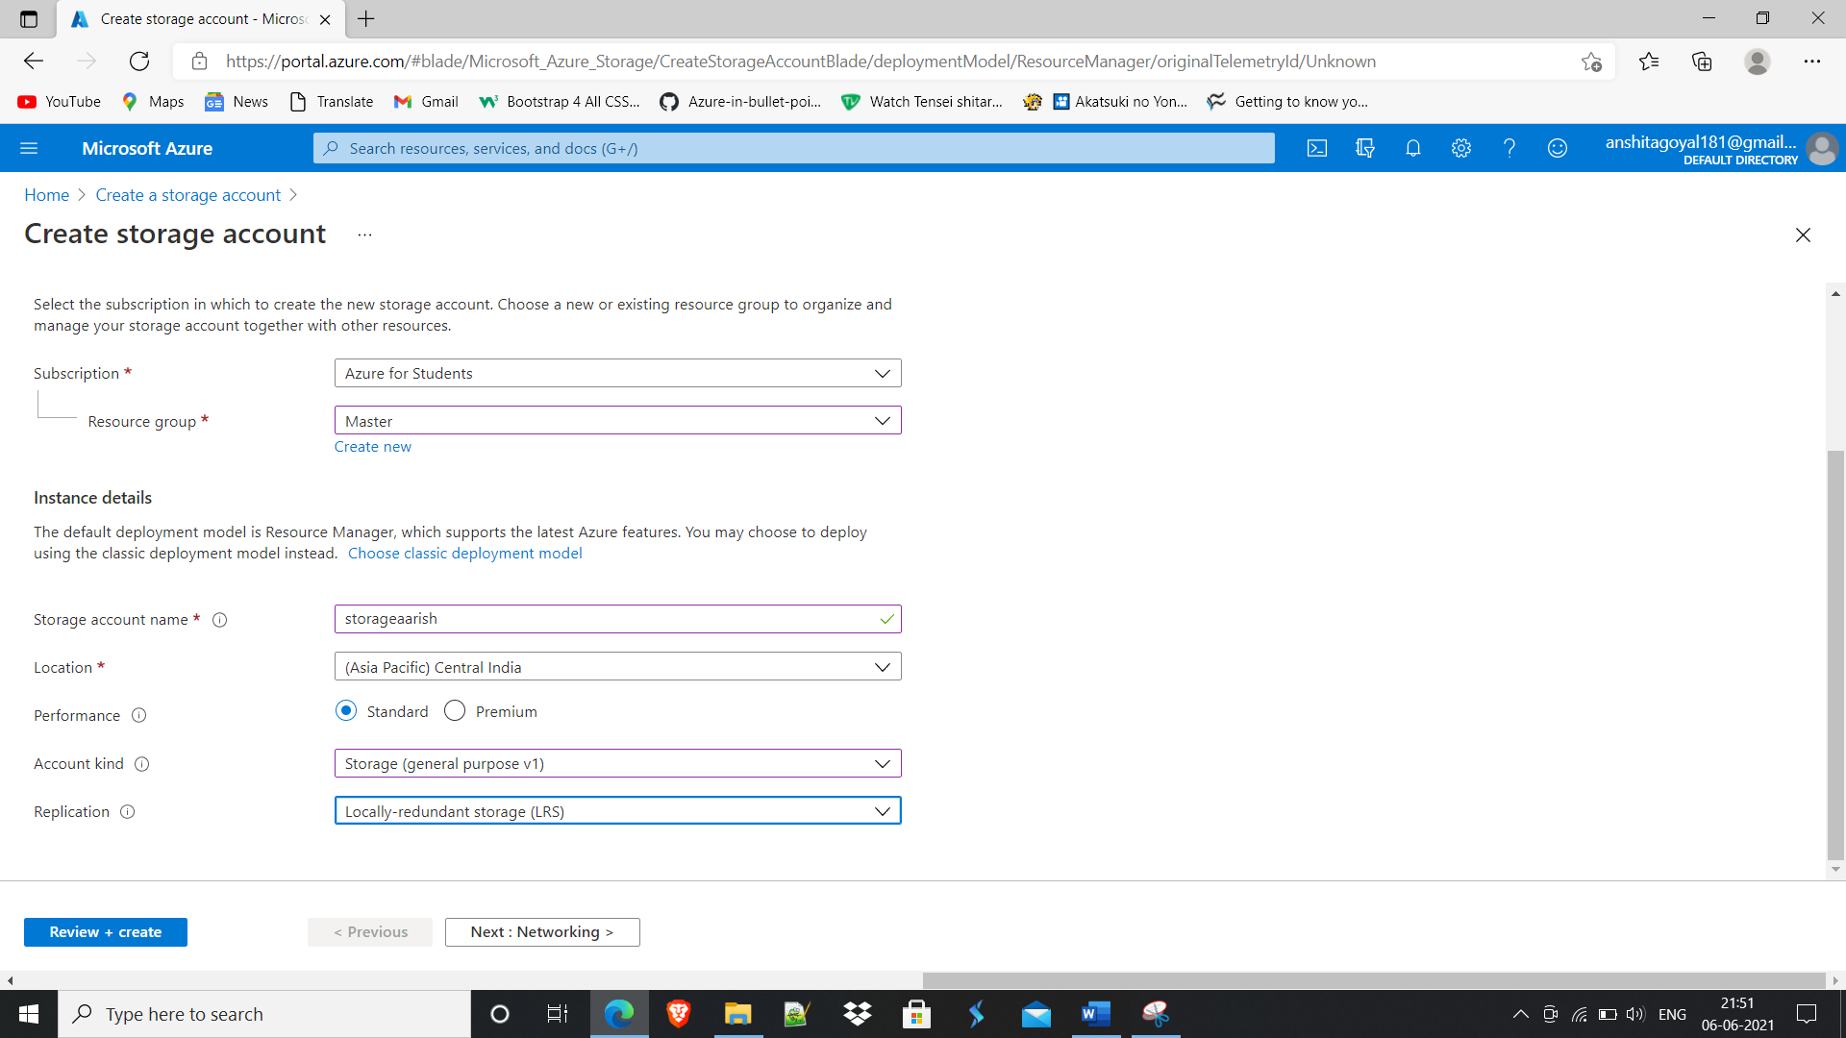

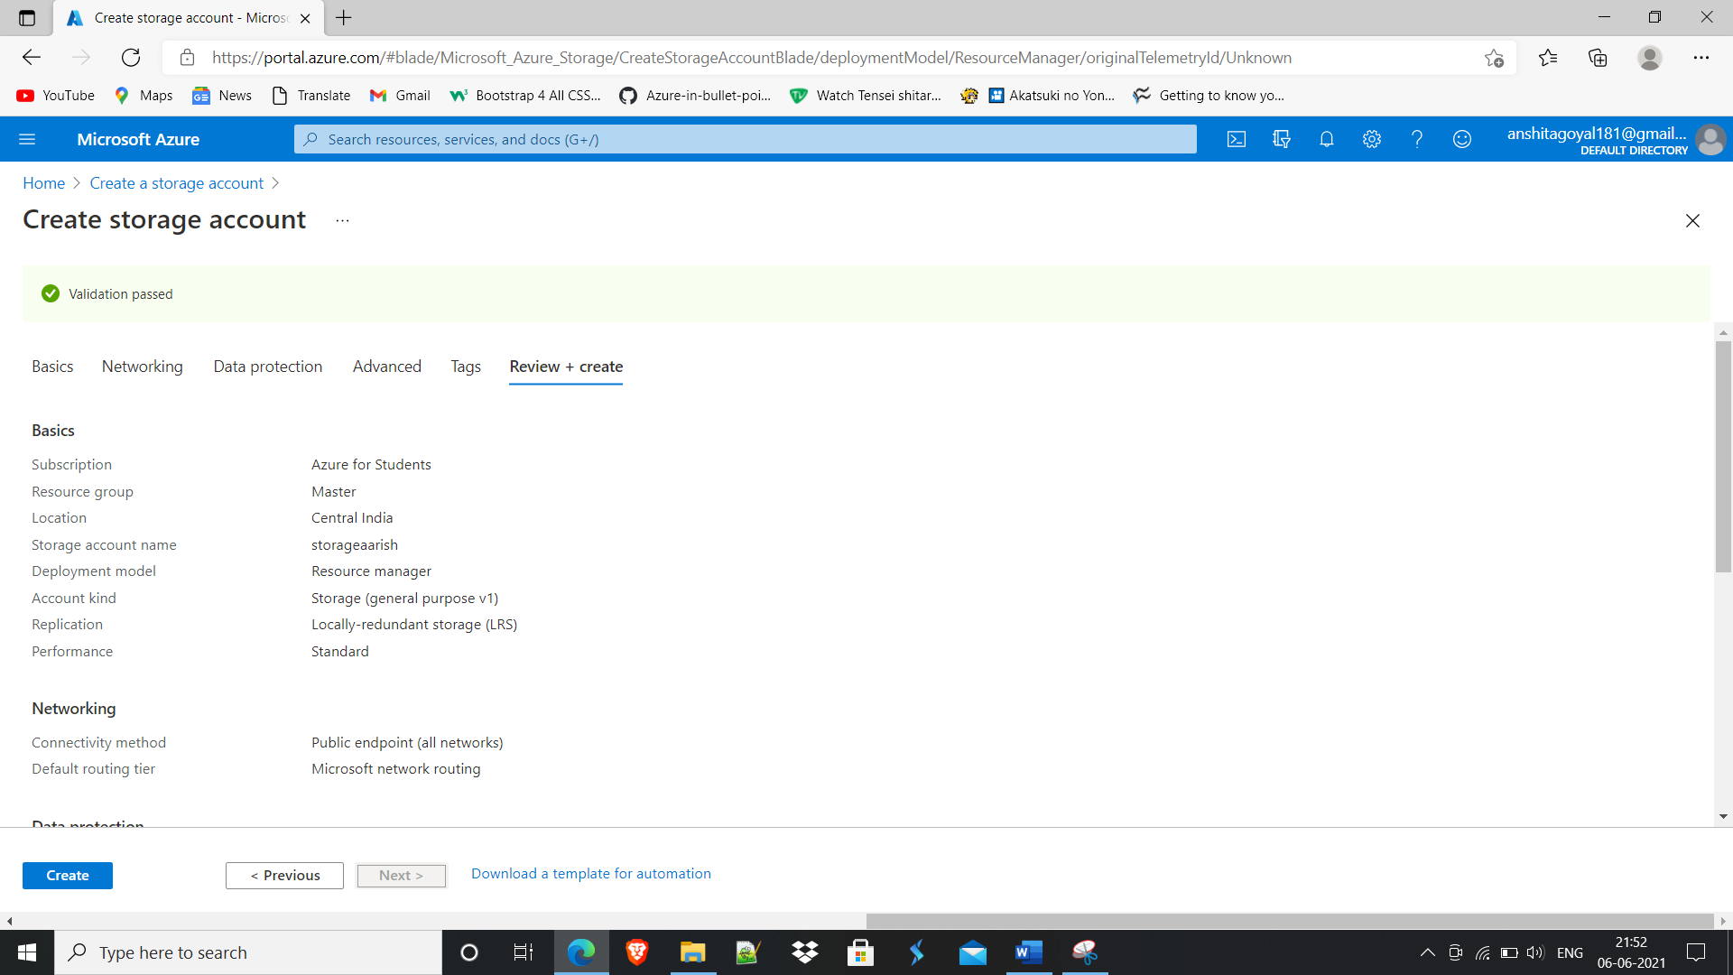

**2. Created Delete type lock on storage account.**

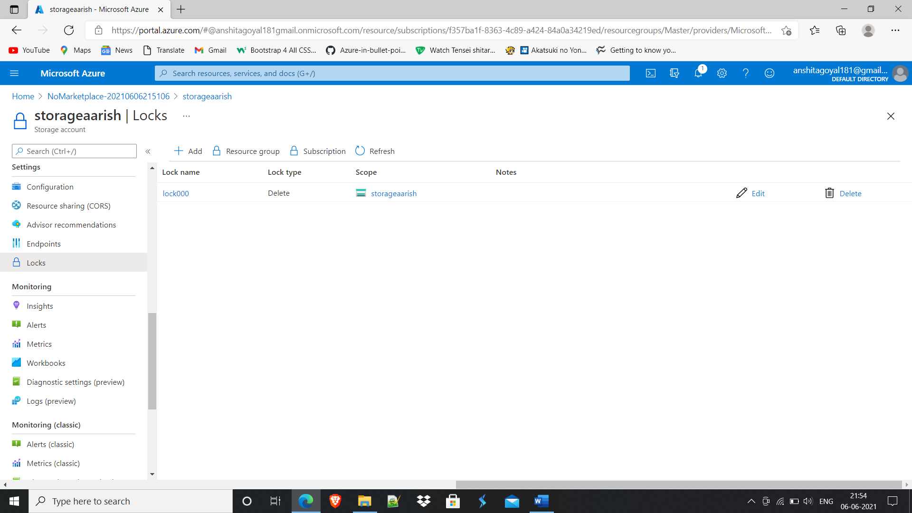

**Q3. Changed the configuration from V1 to V2**

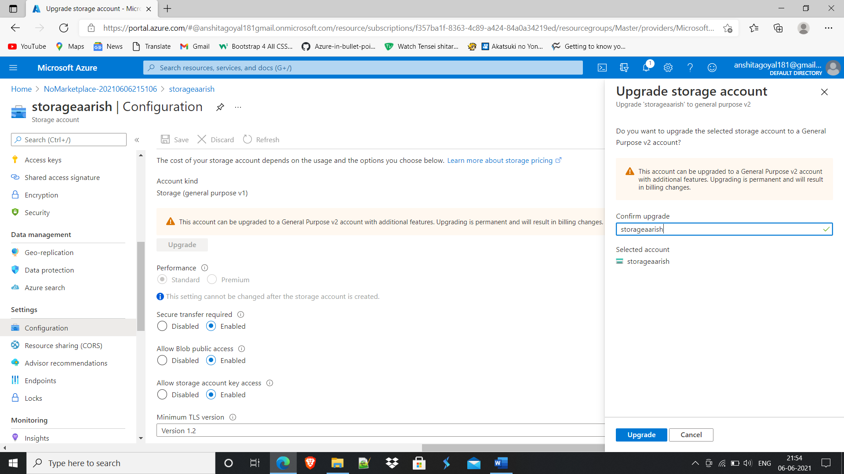

**\*\*\*The** account upgrade happens via a simple **Azure** Resource Manager operation that **changes the** account type. Upgrading a general-purpose **v1** or Blob **storage** account to general-purpose **v2** is permanent and cannot be undone.

**4.1. Created Container and uploaded an image file**

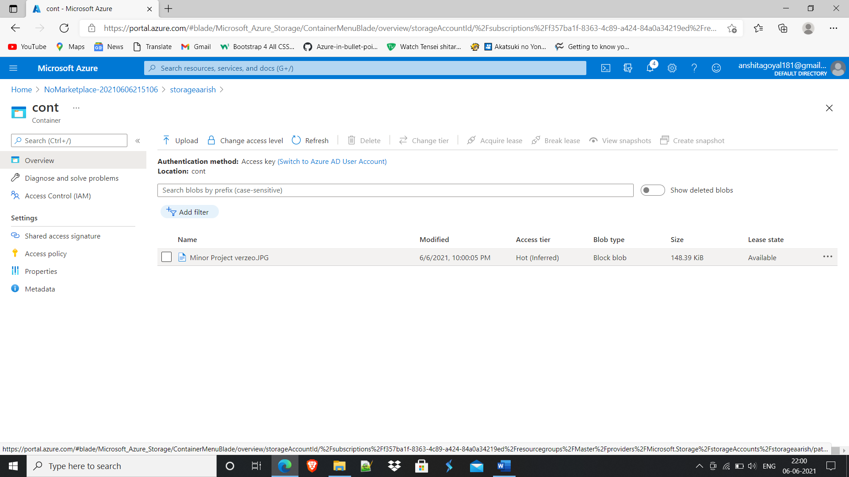

**4.2. Copied image URL and pasted in browser**

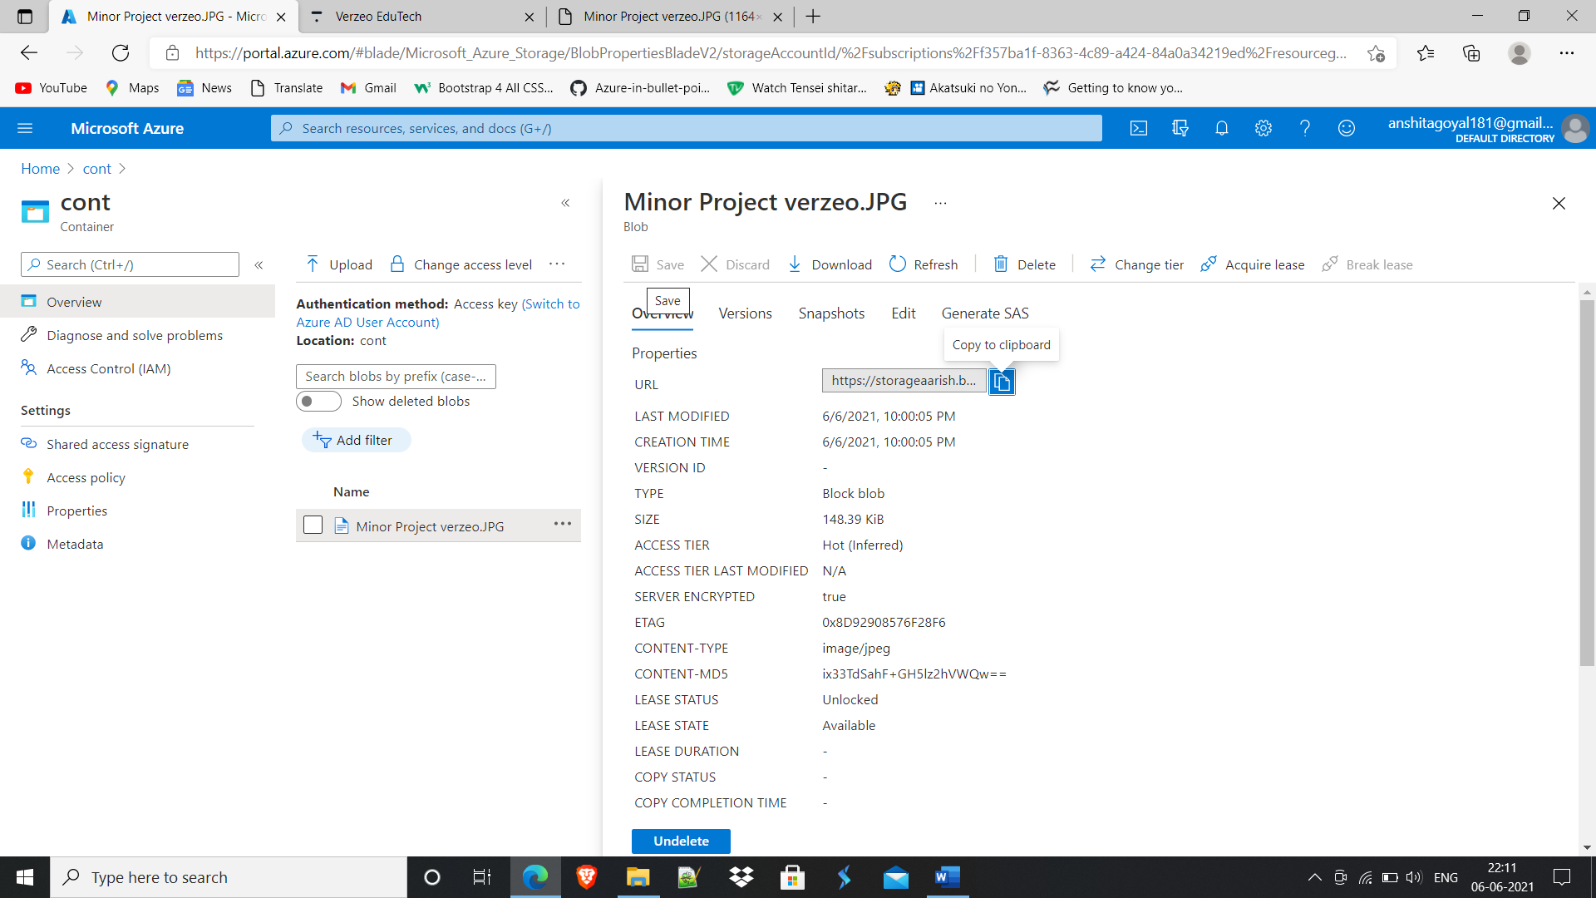

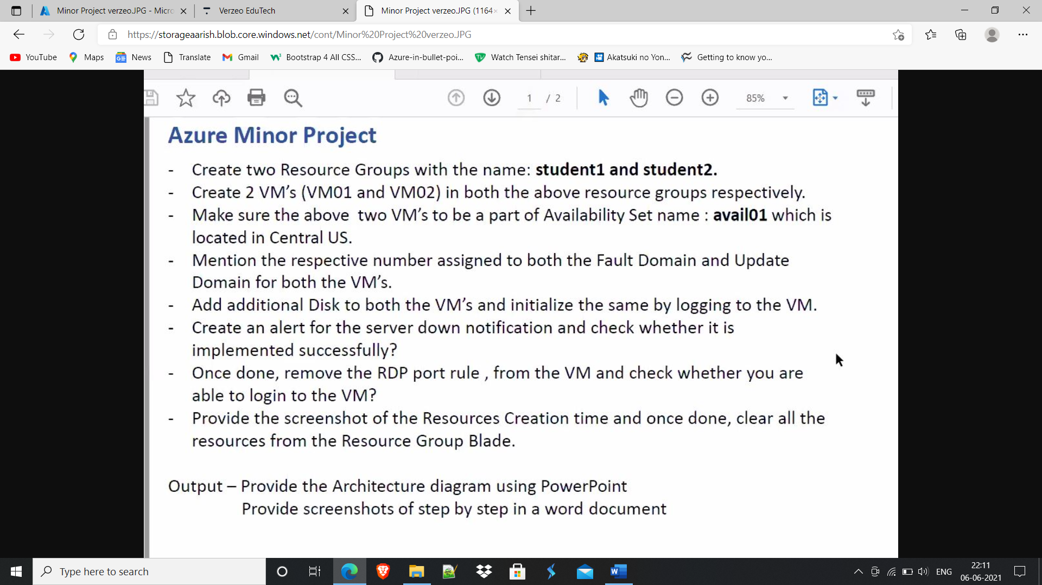

**4.3. Changed access level to private**

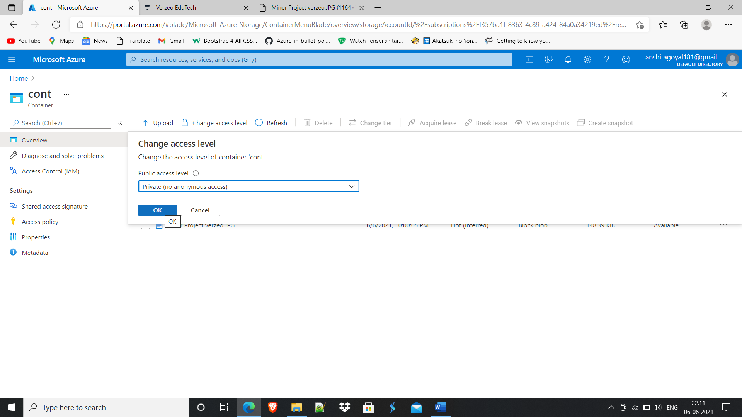

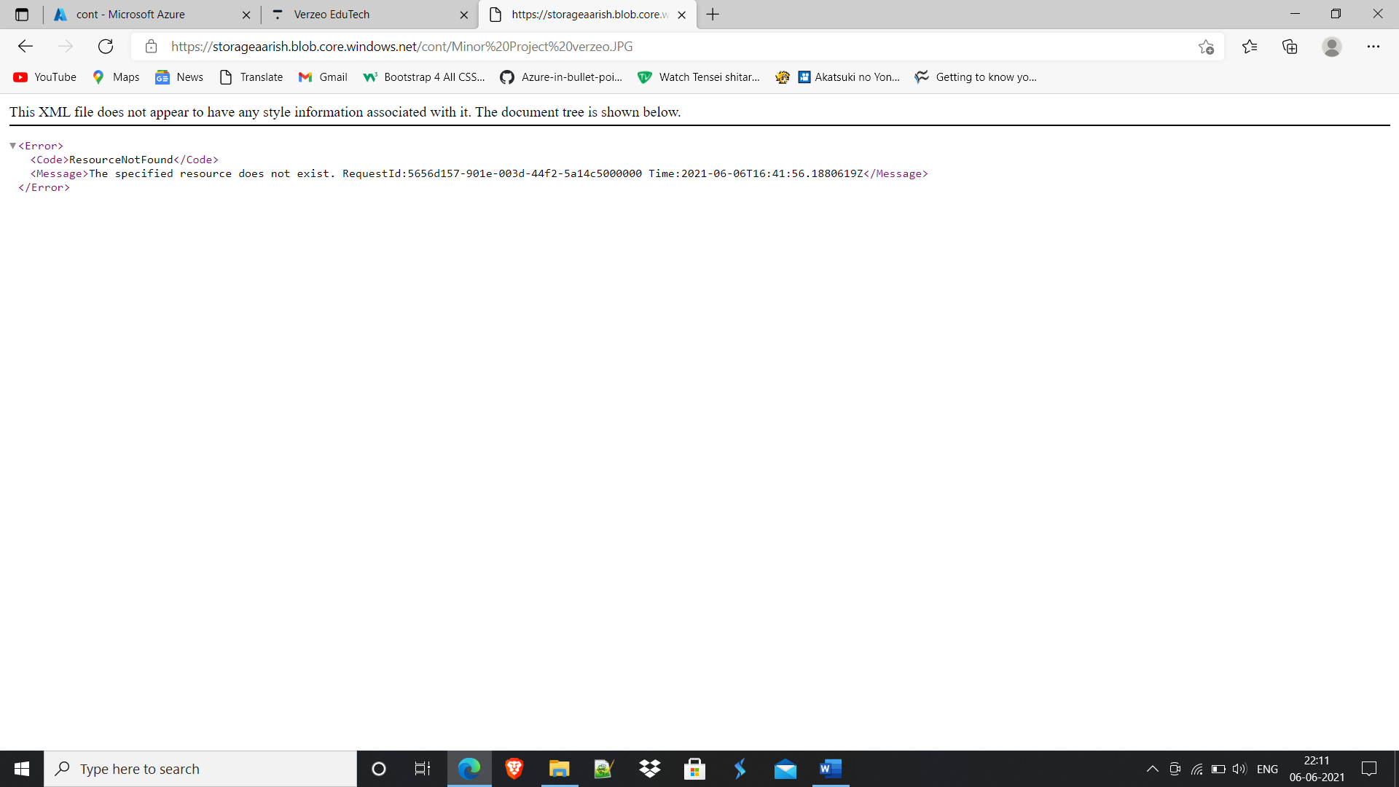

**4.5. Generated SAS signature for 1 month.**

**SAS token copied and pasted in front of image URL in browser**

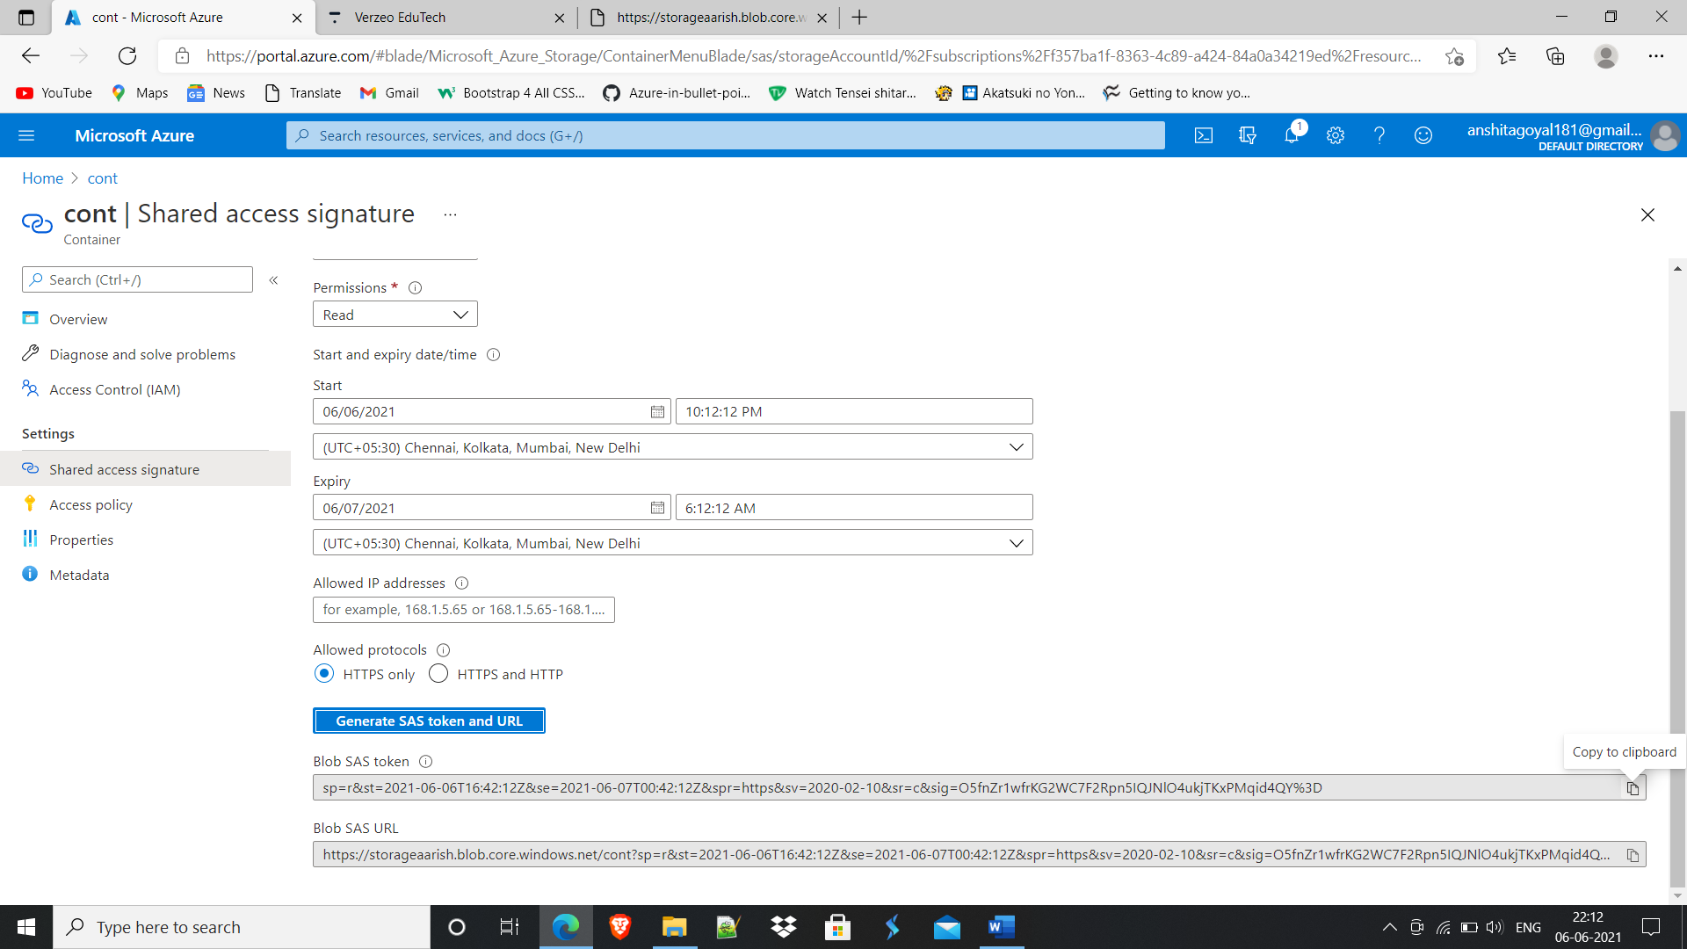

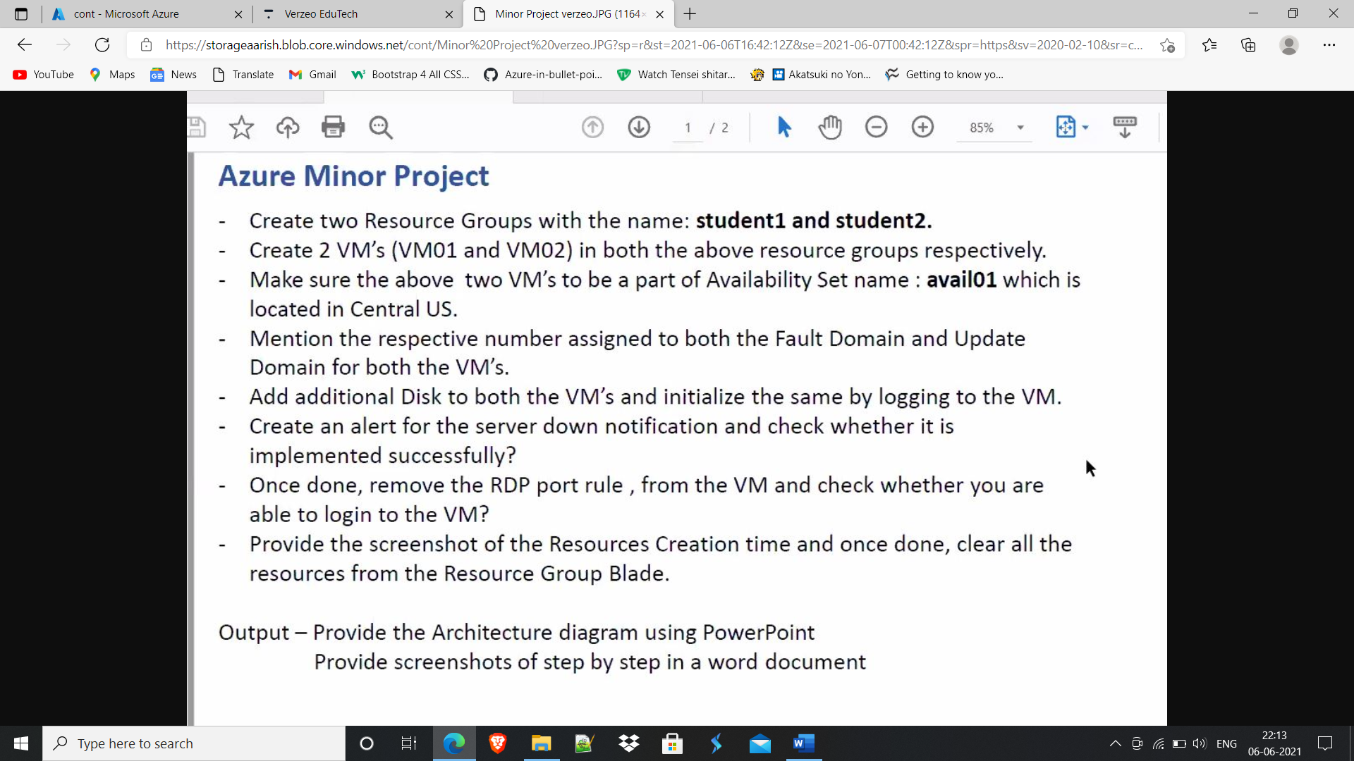

**5.1. When deleting resource below mentioned error shown because of Delete type lock applied**

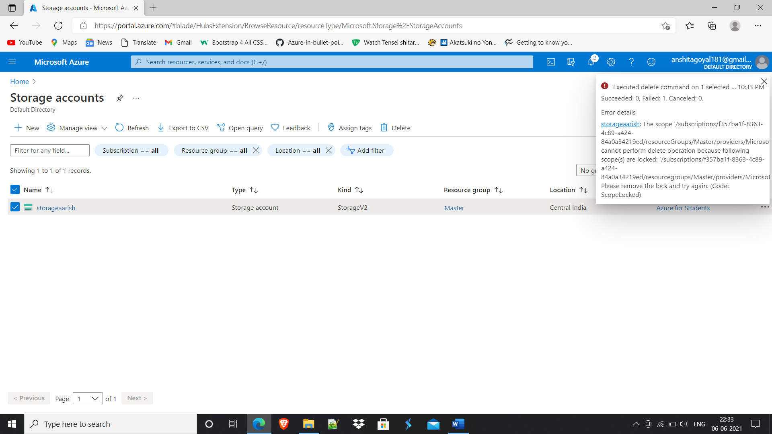

**5.2. Deleted Lock**

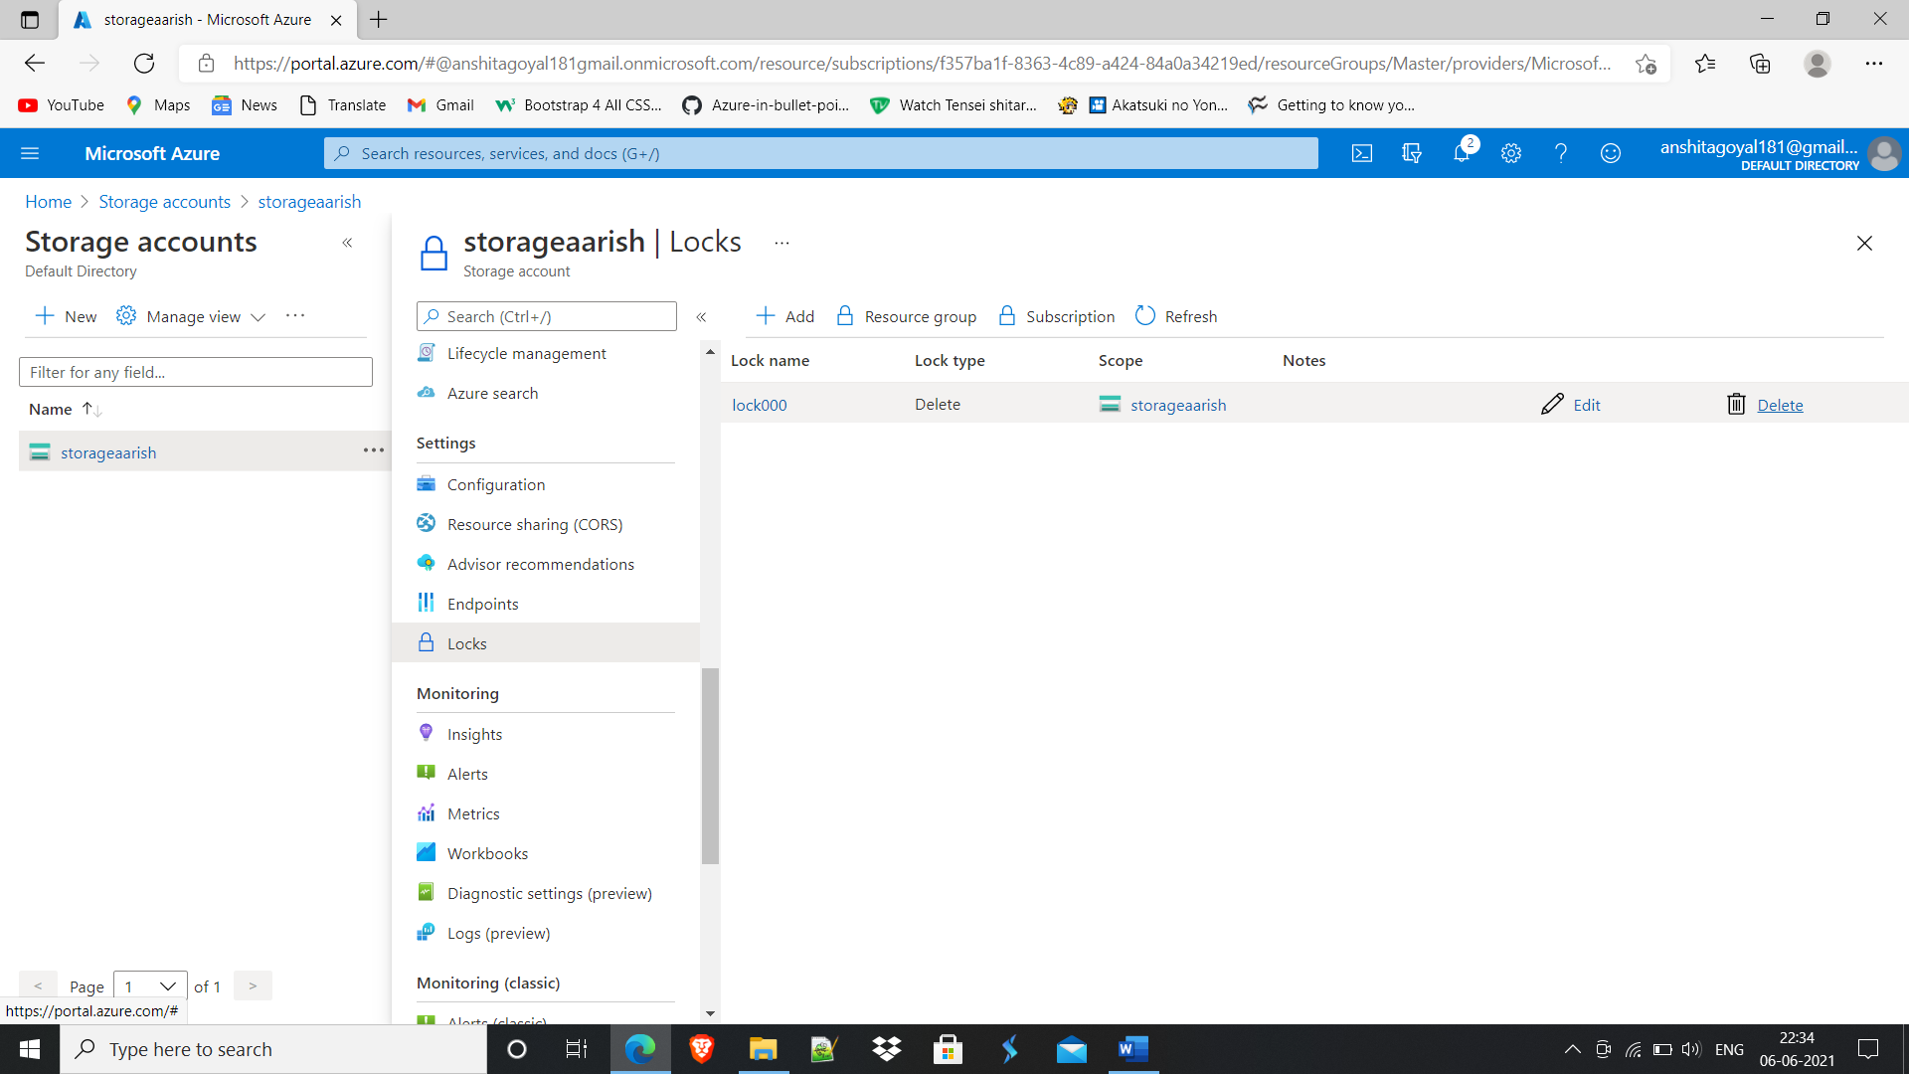

**5.3. Successfully deleted resources**